Sales Performance & Customer Insights Dashboard
Author: Zoha Tabassum
Domain: Data Analytics / Business Intelligence
Tools & Technologies: Python, PostgreSQL, SQL, Excel, Power BI

1. Executive Summary
Modern organizations generate massive volumes of sales data across customers, products, regions, and sales channels. However, raw transactional data by itself does not support strategic decision-making. The objective of this project is to transform large-scale sales data into meaningful, business-ready insights using an end-to-end analytics workflow.
This project delivers a complete Sales Performance & Customer Insights solution, covering data generation, storage, analysis, and visualization. Using SQL for analytical processing, Excel for validation, and Power BI for interactive dashboards, the solution enables stakeholders to monitor revenue trends, identify high-performing regions and products, and evaluate sales channel effectiveness.

2. Business Problem Statement
Organizations face several recurring challenges when analyzing sales data:
- Sales data is often fragmented across multiple dimensions such as customers, regions, and channels.
- Manual reporting processes are time-consuming and error-prone.
- Decision-makers lack a unified view of performance trends and key revenue drivers.
- Identifying top-performing products and regions becomes difficult as data volume increases.
This project addresses these challenges by building a centralized analytics solution that:
- Aggregates sales data across critical business dimensions
- Automates revenue and performance analysis
- Presents insights through intuitive and interactive dashboards

3. Dataset Description
To simulate a real-world enterprise environment, a synthetic dataset was generated using Python. The dataset closely resembles production-scale sales data typically handled by data teams in large organizations.
Dataset Components
- Customers: Demographic and loyalty information
- Products: Product catalog and category details
- Regions: Geographic sales locations
- Sales Transactions: 50,000+ records spanning multiple years
Key Characteristics
- Time period: 2022–2024
- Multiple sales channels (Online, Retail, Distributor)
- Variable pricing, quantities, and discounts
The synthetic nature of the dataset ensures data privacy while preserving analytical complexity.

4. System Architecture & Data Flow
The project follows a structured, industry-standard analytics pipeline:
- Data Generation (Python): Synthetic data creation to simulate enterprise sales systems
- Data Storage (PostgreSQL): Centralized relational database for structured storage
- Data Analysis (SQL): Business metrics and aggregations computed using SQL queries
- Validation (Excel): Aggregated results reviewed and validated
- Visualization (Power BI): Interactive dashboards for decision-making
This layered architecture mirrors real-world data workflows used in enterprise BI systems.
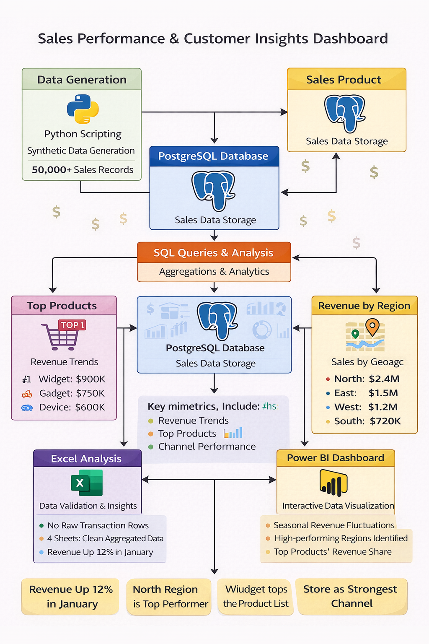

5. SQL-Based Analytics
SQL was used as the primary analytical engine to derive business insights. Key analyses include:
- Monthly revenue aggregation to identify trends and seasonality
- Revenue contribution by geographic region
- Identification of top-performing products based on revenue
- Sales channel performance comparison
Using SQL ensured that heavy computations were handled efficiently at the database level before visualization.

6. Excel-Based Validation
Excel was used as an intermediate validation and analysis layer. Aggregated SQL outputs were imported into a single Excel workbook with multiple sheets:
- Monthly Revenue
- Revenue by Region
- Top Products
- Channel Performance
This step mirrors industry practice where Excel is commonly used for quick verification and stakeholder sharing.

7. Power BI Dashboard Design
An interactive Power BI dashboard was developed to communicate insights effectively. The dashboard includes:
Key Visuals
- Monthly Revenue Trend: Line chart showing revenue changes over time
- Revenue by Region: Bar chart highlighting geographic performance
- Top 10 Products by Revenue: Identification of key revenue-driving products
- Revenue by Sales Channel: Comparison across sales channels
Design Principles
- Clean and minimal layout
- Business-friendly titles and labels
- Focus on clarity and decision support
The dashboard enables users to quickly identify trends, outliers, and performance drivers.

8. Key Business Insights
The analysis revealed several important insights:
- Revenue exhibits clear seasonal fluctuations across months
- A limited number of regions contribute a disproportionately large share of total revenue
- Top products account for a significant portion of overall sales
- Sales channels differ notably in their revenue contribution
These insights can support strategic initiatives such as targeted marketing, inventory optimization, and regional expansion.

9. Business Impact
If deployed in a real organization, this solution would:
- Reduce manual reporting effort through automation
- Improve data-driven decision-making
- Provide leadership with real-time visibility into sales performance
- Enable faster identification of growth opportunities

10. Conclusion
This project demonstrates a complete, enterprise-style data analytics workflow from raw data to actionable insights. By combining SQL, Excel, and Power BI, the solution reflects industry best practices followed by modern data teams.
The project is designed to be scalable, modular, and portfolio-ready, making it suitable for academic evaluation as well as professional review by recruiters and hiring managers.

11. Future Enhancements
Potential extensions include:
- Customer segmentation and cohort analysis
- Year-over-year and month-over-month growth metrics
- Integration with real-time data sources
- Predictive sales forecasting models

